BUCKINGHAM TOWNSHIP
_______________________________________________________________________________________
P.O. Box 413, Buckingham, Pennsylvania 18912 Website - www.buckinghampa.org
Phone (215) 794-8834 ● Fax (215) 794-8837

July 26, 2024

Dear Resident:

We are writing to inform you that a majority of the Buckingham Board of Supervisors voted to reject the proposed DiGirolamo track warehouse project at their meeting on July 24, 2024.

As your elected advocates, the Supervisors denied the proposed project citing that there‘s simply too many unaddressed concerns to warrant allowing this plan to move forward.

The vote continues the Board’s strong record of protecting our community from overdevelopment and working to preserve open space throughout the township. In fact, as of June 2024, Buckingham Township has preserved more than 6,400 acres of land from development.

While the Board of Supervisors was legally prohibited from fully discussing this matter publicly and passing judgement until a formal vote at the township meeting, protecting the environment and the safety and wellbeing of our community and families that live here will always remain at the forefront of any decisions made.

The Board extends to our residents best wishes for a safe and enjoyable summer in the weeks ahead.

We want to extend a gentle reminder to check our website (www.buckinghampa.org) regarding any future warehouse updates or any township business. Also, on Facebook, Instagram, X or join our email alert system to stay on top of things. You can join using this QR Code (or directly on our website).

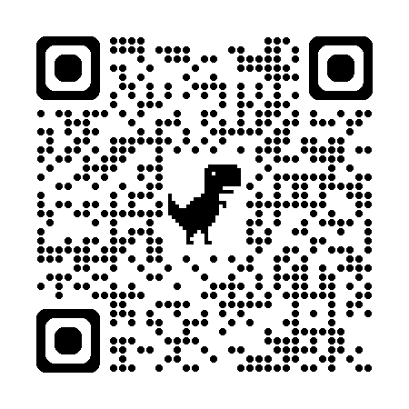

Sincerely,

Paul Calderaio Jon Forest
Chairman Supervisor

